Final Project Design Phase
Computer Science - Week 11
Oct 3, 2026 - Version 0.0.4

For complete instructions and project ideas, refer to the assignment in Canvas. Specifically, review the final project requirements before you continue below. If you have not reviewed the project requirements in Canvas (you might have to go to the modules view and check the current or past week's content), you will not be able to properly complete the parts below. In addition, it may be helpful to review the information on this Drafter documentation page.

0) Project Planning and Preparation
Successful programmers spend time planning before they begin coding. After reviewing the project requirements, answer the following questions to help guide your design and development process.
- What concepts from class or previous assignments might help you complete this project? Which programming concepts (loops, conditionals, lists, classes, etc.) do you expect to use? What programming skills do you want to improve while completing this project?
I expect to use the dataclasses for goal and state list to hold my goals for loop to then count and show the tasks, use the if for checks and for the messages to say whats going on. Functions that will have some doc strings and unit tests to test the functions to make sure each work. I will see how to run this program all on drafter ad make sure that it works.

- Which parts of the project do you expect to be the easiest for you? The hardest? Why?
The easiest parts of this project should be I say the home and profile page since they wont have much functions to them really just a save or other inputs. The hardest part will most likely be the check in route which has to find the right goal and list to then update it to. The day score as well since it has to know the right numbers and give the right answer back.

- Even though you have not yet designed the final project, estimate which tasks will likely require the most time and effort? Which features or components should be implemented first?
The most time will mostly be going in the routes that change the goals list and writing in some tests to make sure stuff will work. I will look into building the main home page first to get the good base down then simply add the pages from there and add their functions to each one.

- What distractions might interfere with your work and how will you minimize them? What resources will you need available while working? What questions, if any, do you still have about the assignment requirements?
My phone will definitely be #1 so I must put my phone away and lock in for a bit to get this done. I will need my computer as the main resource but I would want to be in an open room like my lounge and keep up to date on everything to not get left behind. If any questions come up I will go to prof office hours to get looks on what might be happening. I need to start working on it and as stuff comes up.

1) Site Diagram
Create a mock-up of your planned website. We suggest you make the mockup on paper, although you can also use software like PowerPoint or Slides to make a mockup. There is other design software that could also be used, but we strongly encourage you to keep it simple. Do not spend more than 15-30 minutes detailing the mock-up. Your goal should be to make a very quick and dirty diagram, to show that you have some kind of idea.

We recommend drawing each page as a rectangle, and laying out the text, buttons, and other components inside. Then, use arrows to indicate links between pages. Label each page the way you will name each function, and then put labels on the arrows to indicate what the button links. Also write down any parameters that should come into the pages.

In addition to the pages and routes, write down what fields your `State` will have, both their names and types. Think clearly about what data will need to be persistent across the entire website.

Add photo(s) or screenshot(s) of your website mock-up and labeled diagram on the next page.

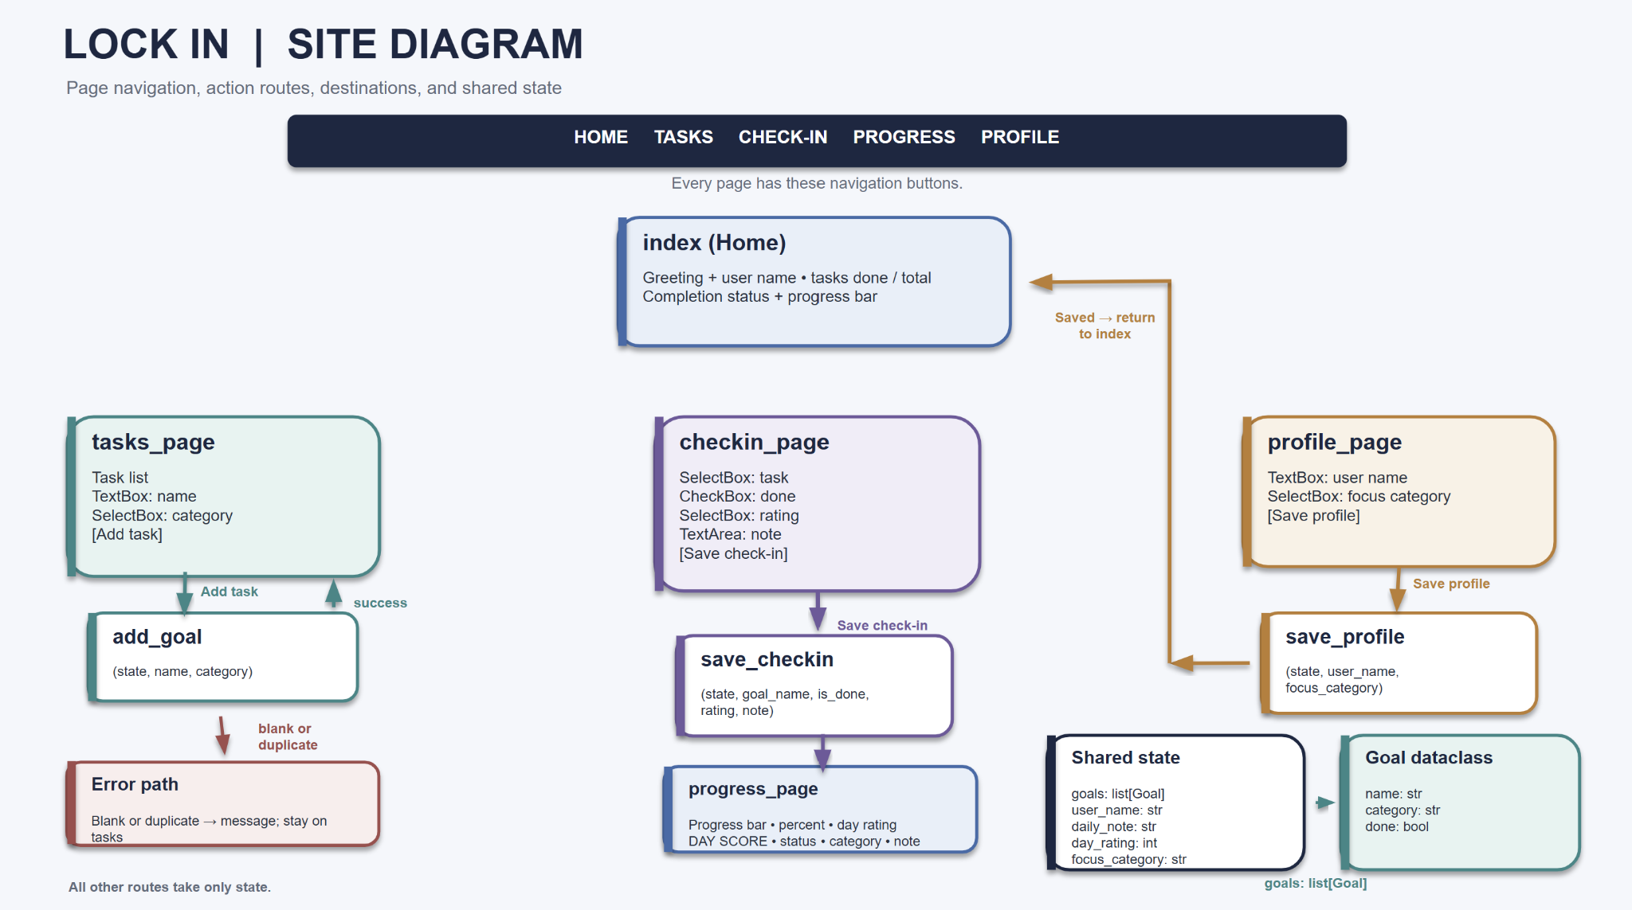
2) Implementing Requirements
This table should serve as a draft for how you will implement the requirements into your final project. You may change your ideas later on, but your final site must fulfill all the requirements.

Requirement | Implementation
Purpose/Functionality  A 1-2 sentence description of the purpose or functionality of your site | Lock in is a daily tracker users will add task/goals for the day and check them off and rate how the day is going to see a day score that shows if they are locked in or not.
State Dataclass Attributes  Minimum of 4 attributes, one of which must be a list/dict of instances of your second dataclass.  Briefly describe each attribute, its type, and how it will be meaningfully modified throughout the site. | Goals:list[goal]-that users input of tasks appends it to add goal function and save checkin updates a task done value  User name:str- will be in set a profile and user to greet in the home page  Daily note: str-set it in the save checkin page and will be shown with the progress bar.  Day rating: int-set it in the save checkin page to check a 1-5 box on the day to use in day score  Focus category: str-set in the save profile
Second Dataclass  Your second dataclass, including its attributes, their types, and how they will be meaningfully modified (if they are modified) | Name :str ,category: str and done: bool the name and category are going to be set when a task is added and done changes when the user save a check in
Routes (minimum 7)  The names of your route functions | Index,tasks_page,add_goal, checkin_page, save_checkin, progress_page, profile_page , save_profile
Pages (minimum 5)  A brief description of the pages in your site | Home: will have a greeting how many task done and progress bar  TASKS: list of tasks and where to add tasks  Checkin: update a tasks rate the day and write a note  Progress: percent, day score, status, and a category breakdown.  Profile: set name and focus category
User Input (minimum 3)  Description of user input components (TextBox, TextArea, CheckBox, or SelectBox) and their purposes  For more information on these input types, see Drafter Documentation. | Textbox:task name and user name  SelectBox:task category, which task to check off,day rating  Checkbox:whether the task  Textarea:note for the day
If Statements (minimum 3)  Brief description of what will be evaluated in your if statements and how they will meaningfully change the logic of the site | Blank name check in goal stops the empty tasks.  Double check in the goal repeated tasks.  If the goals list is empty, the tasks page and check-in page show a ‘No tasks yet’ message instead of an empty list  Greeting check and shows different greeting on a name  Status check in is whether it shows locked in, on track, or need a push.
Loop (minimum 1)  This loop must iterate over the list/dict of dataclass instances in your State attribute.  Description of this loop and why it is meaningful to the site | Count_done loops over every goal in the goals and checks if the goals are done to get the percent complete. Goal_line loop over the goals to build each task page. Then the save checkin will loop over the goals to find the one the user wants to pick.

LLM Conversation
If you used an LLM in any part of this work, copy and paste every part of that conversation below. Otherwise, you may be given a zero for the assignment. Obviously, these words will not all be yours, and this is the exception to the requirement at the top of this assignment that all responses be in your own words. If you did not use an LLM to assist you in this assignment, simply say so below.
i need to do cisc 106 for udel final project this is the the beginning

Nothing came through with your message, so I’m not seeing the beginning you meant to share. Could you paste it here as text, or re-upload the file? That could be the worksheet, the assignment prompt, or your starter code.

If you’re working on the Lock In Drafter project, the daily task tracker, I can pick up from there. Once I can see what you have so far, I can help with the next step, whether that’s the Week 10 worksheet or planning the build. I’ll keep any code to techniques covered in CISC 106.

I want this project to be able to take in a goal or task for the day and track how many things i do and keep track at how well my day is going so give me anything way that the project can look

Here are a few ways Lock In could look. Each one covers your three needs: entering a task or goal, counting what you finish, and tracking how the day is going.

1. Single dashboard page (simplest)

The top shows the title “Lock In” and a big line like “3 of 5 tasks done.”
A text box and an “Add task” button sit under that.
The task list comes next, with a “Done” button beside each task.
At the bottom, three mood buttons (Locked in / Okay / Off track) set how the day is going.

This is the easiest to build and the easiest to explain on a worksheet.

2. Three-page flow (morning, midday, night)

Morning page: enter your main goal for the day and your tasks.
Today page: check things off and see the running count and a progress message.
Evening page: rate the day and see a summary, like “You finished 4 of 5 tasks and rated the day 4/5.”

This feels like a daily routine, and it makes good use of Drafter’s multiple pages.

3. Score-based “lock-in meter”

Every finished task adds points.
Your mood rating adds or subtracts a few more.
The page shows a score and a label that changes as it goes up, like “Warming up,” “Locked in,” or “Fully locked in.”

This makes it feel like a game, and the score logic is a nice thing to point to for grading.

4. Goal-first layout

The big “Goal of the day” sits at the top in large text.
Smaller tasks sit underneath as steps toward that goal.
A progress line reads “2 of 4 steps toward your goal.”

This is the best fit if you want the goal to matter more than a plain to-do list.

You can mix them, for example the three-page flow with the meter on the Today page. As a starting point, I’d suggest option 2 with the score from option 3, because it covers everything you described without much complexity.

Which one do you like most, or which mix? Then I can help you fill in the worksheet or plan the build.

"I want to build a simple web tool to help students track their study hours. What are 3 common problems students face when tracking their time, and what are 3 simple features a basic tool should have?") ask this question for my website

Preparing a reply about the Lock In website.

Here are answers you can use for Lock In, tailored to a daily task and study tracker.

3 common problems students face when tracking their time

Forgetting to log it. Students start a task, get busy, and never write down what they did or how long it took, so the record ends up incomplete.
Not knowing what to do first. Without a clear goal for the day, students jump between tasks and lose time deciding what matters most.
No sense of progress. A long to-do list feels endless, so students can’t tell whether the day is going well and lose motivation.

3 simple features a basic tool should have

Task or goal entry. A text box where you type a goal or task for the day and add it to a list. This solves the problem of not knowing what to do first.
A completion counter. A “Done” button on each task and a running count like “3 of 5 tasks done.” This solves the problem of seeing no progress.
A daily check-in. A simple rating, such as Locked in, Okay, or Off track, that records how the day is going, with a short summary at the end. This makes logging quick and builds the habit of reflecting on the day.

Each feature is easy to build with Drafter using only text boxes, buttons, and basic state, so it fits the techniques taught in CISC 106.

If your worksheet question is specifically about study hours rather than tasks, I can adjust the answers to include a time-logged field, like “hours studied today.”

Explaining reasons behind the requested fixes.

Each change was either a missing requirement, a point you could lose, or a clarity problem. None of them were me redesigning your project.

Changes that protect your grade

The fifth page. The worksheet asks for at least 5 pages, and you described 4. A grader counting pages would mark it short, even though your routes already include profile_page.
Types on the State attributes. The table says to give each attribute’s type. Without types, that row is incomplete.
The full LLM conversation. The worksheet says you may get a zero if an LLM was used and the conversation isn’t pasted in full. This one carries the biggest penalty, so I wanted it clean and complete. I also said to remove the interface lines because they aren’t part of the chat.
The missing site diagram. It’s a required section, and right now it’s empty.

Changes for clarity

The unfinished and garbled sentences. A grader has to understand what each if statement and input does. “Checkbox: whether the task” and the empty-message sentence don’t say that clearly.
Naming real functions in the loop row. The table asks you to describe the loop and why it matters. Naming the actual functions, like count_done, shows you know where the loop will live in your code, and it makes Week 12 easier.
Typos. They’re minor, but they make the worksheet look rushed.

What I left alone on purpose

I didn’t touch your Section 0 answers or your overall design, because they were already specific and in your own words, and the worksheet requires that.

If you disagree with any of these, tell me which one. For example, if you’d rather keep four pages and check the Canvas rubric first, that’s reasonable, and I’d just suggest confirming the page count there before you submit.

Final Project Design Phase Computer Science - Week 11 Oct 3, 2026 - Version 0.0.4 For complete instructions and project ideas, refer to the assignment in Canvas. Specifically, review the final project requirements before you continue below. If you have not reviewed the project requirements

PASTED

what you think about it nnow

It’s much better. The worksheet now meets the requirements on paper, and what’s left is mostly cleanup plus the two empty sections.

Now fixed

You have 5 pages, with Progress and Profile described.
The empty-list if statement is clear.
The loop row names real functions.
You have 8 routes, 5 if statements, and 3 loops, all above the minimums.
Each of your 5 State fields is changed by a route, which covers the “meaningfully modified” requirement.

Still to fix

State attribute types are missing. The table asks for each type. Add them next to each one, such as goals: list[Goal], user_name: str, daily_note: str, day_rating: int, and focus_category: str.
The Goal dataclass line starts with “Goal:str.” The first attribute should be name: str, so it reads: name: str, category: str, done: bool.
“Checkbox: whether the task” is still unfinished. End it with “is done.”
The LLM Conversation section only has a period. This is the biggest risk, since the worksheet says you may get a zero without the full conversation. Paste the whole chat from the beginning, with “Me:” and “Claude:” labels.
The site diagram is still missing. It’s a required section. Five page boxes, route names on the arrows, and the State fields in a side box is enough.

Small wording cleanups

“Goal_line loop over the goals to build each task page” would read better as “build each task row on the tasks page.”
“will be in set a profile and user to greet in the home page” is hard to read. Try “set on the profile page and used to greet the user on the home page.”

Once those five items are done, this is ready to submit. After that, the next thing to decide before the Week 12 build is the score formula and the status cutoffs.

what would be the best way to go about the flow chart

Keep it simple and do it on paper or in Google Slides, whichever is faster for you. Since your worksheet is in Google Docs, Slides works well because you can paste the picture straight in. Plan on about 15 to 20 minutes.

Step by step

Draw five big rectangles, one per page, and title each with the function name: index, tasks_page, checkin_page, progress_page, profile_page.
List the components inside each box, like “greeting,” “progress bar,” “TextBox: task name,” “SelectBox: category,” and “Button: Add task.”
Add the save routes as small boxes or as labels on arrows: add_goal, save_checkin, save_profile. These don’t show a page of their own, they just update State and send you somewhere.
Draw arrows and label each with the route or button name. Here is the flow from your worksheet:
index has buttons to tasks_page, checkin_page, progress_page, and profile_page.
tasks_page has an “Add task” button that goes through add_goal and returns to tasks_page.
checkin_page has a “Save check-in” button that goes through save_checkin and lands on progress_page.
profile_page has a “Save profile” button that goes through save_profile and returns to index.
progress_page has a “Back” button to index.
Draw a State box off to the side listing the fields and types: goals: list[Goal], user_name: str, daily_note: str, day_rating: int, focus_category: str. Add a second small box for Goal with name: str, category: str, done: bool.
Note the parameters. In Drafter, every page and route takes state as a parameter, so one line saying “all pages receive state” covers it.

Tips

Use one color for page boxes and another for save routes, so the difference is obvious at a glance.
If an arrow crosses another one a lot, move the boxes around. Putting index in the middle with the other pages around it keeps things tidy.
Don’t draw detailed buttons or styling. Rough is what the assignment asks for.

If you’d like, I can make a clean version of this flow in the chat for you to copy from. Your own sketch would be better to submit, since the diagram is supposed to be your work.

Final Submission
When you are finished, download this file as a Word Document (docx) and upload the file to the appropriate assignment on Canvas.

